Causes of Infertility and how to administer treatment
Name
Institution

Causes of Infertility and how to administer treatment
Infertility is a condition that makes it hard for parents to conceive, the condition can affect both men and women. According to (women's health .gov, par. 1), one is declared infertile after trying to conceive for one year without any success, and for women aged 35 and above, if after trying for six months, one can still not conceive she is declared infertile. With improved technologies, people who have infertility can now receive medication or alternative methods on how to conceive.

("Infertility: Various Types of Infertility in Humans and its Treatment", 2018)
Statistical Data
Research has shown that couples affected with fertility issues make up 15% of the total population globally. That is an estimated 48 million couples. The study was further dis-integrated the study, and 20-30 % of infertility cases were found to be due to men. It was also seen that 50% of infertility cases were caused by men. However, this statistics might not apply to the entire world since it differs in different regions.
Types of Infertility
On the other hand, research has shown that women affected by secondary infertility are more compared to those who experience primary infertility. Primary infertility is experienced by a woman who has never conceived, while secondary infertility occurs to a woman who has previously conceived but is unable to conceive a second time. In 2010, research conducted showed that approximately 10% of women across the globe experience secondary infertility, (Insler & Lunenfeld, 1993), whereas the prevalence of primary infertility is around 2%. However, it is important to note that this numbers may vary in different regions due to the living conditions, sexual health as well as awareness in the community.
Causes of Infertility
It is clear that infertility is an issue affecting both men and women, but the reasons to infertility vary depending on various factors. Some of the reasons women suffer from infertility include;
- Infertility in women may be due to a congenital disability, some women cannot conceive from as young as 15.
- Damage to the fallopian tubes, fallopian tubes can be destroyed due to various conditions,
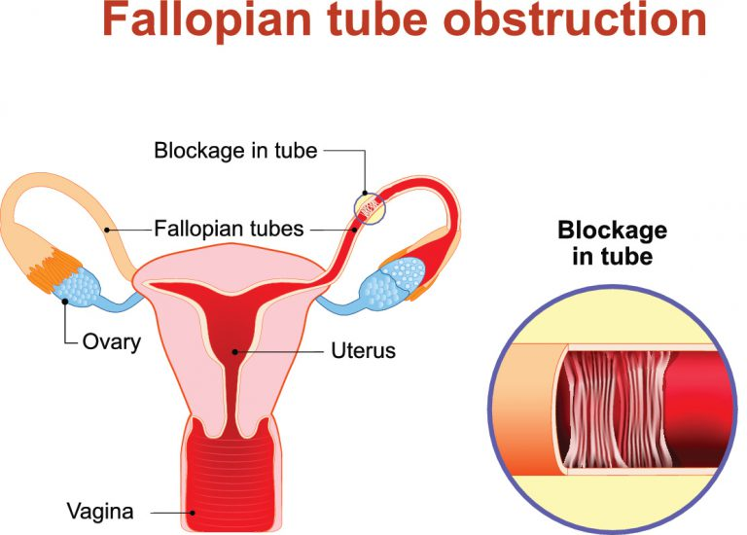 (Watson et al., 2018)
An infection, it is essential for women to be keen when it comes to their health, this is because the infection can cause damage to your fallopian tubes leading to infertility. Fortunately, when detected early infections can be treated safeguarding the fallopian tubes.
An inflammatory condition, this condition can also be treated to avoid severe outcomes such as infertility.
Endometriosis
Endometriosis, this is a condition that affects the uterus when the uterus is covered by a layer of tissues, a study conducted in America showed that about 11% of American women aged between 15 and 40 years old suffer from endometriosis.
- The other leading cause of infertility is ovulation problems. For a woman to conceive it is critical for her to ovulate. Some of the factors that may cause problems with ovulation include: Stress, when one is under pressure, the body is affected not only on the outside but the inside. Fortunately, one can treat anxiety, with medication and seek help form loved ones or a professional.
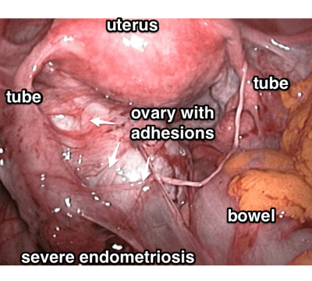
("Endometriosis Diagnosis | Endometriosis & Miscarriage", 2018)
Hormonal imbalances and irregular menstrual cycles
Hormonal imbalances, the excess production of certain hormones may disrupt ovulation leading to infertility. Hormones can be balanced making it easier to deal with infertility when one is under medication. Irregular menstrual cycles, some menstrual cycles are too short, in case this happens, it is advisable for one to seek medical advice, it may lead to infertility, but when the issue is addressed early enough it is resolved.
Reasons that may lead to infertility in men
Some of the reasons that may lead to infertility in men include;
- Low sperm count, this is one of the most common causes of infertility in men, to determine whether the number of sperms is low it is important to undergo a test. Low sperm count may be certain medications, infections as well as radiation.
- The transportation system of the sperms may be blocked; this may be caused by infections, vasectomy or lack of deference.
- Men may also experience infertility due to hormonal imbalance; this may happen in men when one abuses steroids, it may also be due to tumors.
- Erectile dysfunction, the sexual problem is also another factor common in causing men infertility. Erectile dysfunctional can be due to use of certain medicines, infrequent sex, spinal injury, prostrate operation, or damaged nerves.

Effects of infertility
Infertility, especially for a couple aspiring to raise a family, may be overwhelming. The community also has strong opinions over couples without children, and this may be overwhelming for those affected by the problem. In some parts of Africa, women face harsh critiques when they are unable to bear children since some African cultures peg the value of a woman on the ability to give birth. This, in turn, leads to discrimination and stigma and may lead to depression and low self-esteem.
Treatment of infertility in men
Fortunately, medical research has improved, and methods to treat infertility have advanced, and people are now able to conceive. In the case of infections when detected early enough one can receive medications that will ensure there is no recurrence of such an infection again. Men who have become infertile due to prostate surgery, (Falcone & Hurd, 2007) medical improvements have come up with procedures that ensure that men can still function normally and the issue of erectile dysfunction eliminated.
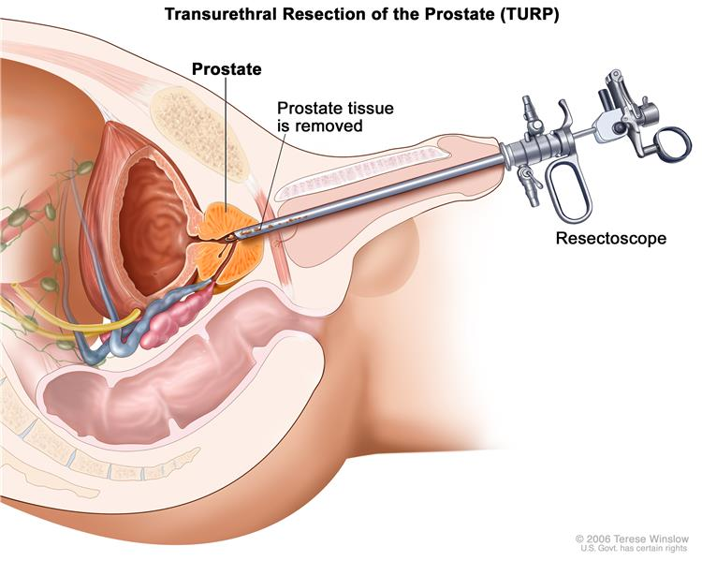
("Prostate Cancer Treatment", 2018)
Solutions to hormonal imbalance and blocked fallopian tubes
In the case of hormonal imbalance, thousands of patients have received treatment that has helped to balance their hormones; (Sjöberg, Ahlgren, Lalos, WHO, & UN, 1989) these medications regulate the number of hormones produced in one's body in the case of excess production of certain hormones. In the case of damaged fallopian tubes, there are surgical procedures designed to eliminate the problem for instance fibroids.

Alternative methods to deal with infertility
Medical research has shown that some cases of infertility are due to congenital disabilities; in such a situation treatment is not an option. Couples are therefore advised on several options that can help them in starting a family.
Surrogate mothers
One of the alternatives is surrogate mothers, in the case where the woman is unable to conceive, the couple can use a surrogate mother who will help the couple in carrying their pregnancy until birth. This has assisted many couples in establishing happy families.
Sperm donors
When the man is infertile, the couple may consider using donated sperms, and the woman is inseminated, and they successfully get their desired family. Infertility is a common issue, among couples. However, medics and researchers have invested in ensuring that there are some alternative methods and treatments to help the affected persons.

References

Falcone, T., & Hurd, W. W. (2007). Clinical reproductive medicine and surgery. Philadelphia: Mosby.

Hodin. S. (2018). The Burden of Infertility: Global Prevalence and Women’s Voices from Around the World, retrieved from https://www.mhtf.org/2017/01/18/the-burden-of-infertility-global-prevalence-and-womens-voices-from-around-the-world/

Insler, V., & Lunenfeld, B. (1993). Infertility: Male and female. Edinburgh: Churchill Livingstone.

Sjöberg, N.-O., Ahlgren, M., Lalos, A., World Health Organization., & United Nations Population Fund. (1989). Guidelines on diagnosis and treatment of infertility. Copenhagen, Denmark: World Health Organization, Regional Office for Europe.

Womenshealth.gov,(n.d) Infertility, retrieved from https://www.womenshealth.gov/a-z-topics/infertility.

Endometriosis Diagnosis | Endometriosis & Miscarriage. (2018). Reproductive Immunology. Retrieved 25 April 2018, from http://www.preventmiscarriage.com/diagnosis-of-endometriosis.html

Infertility: Various Types of Infertility in Humans and its Treatment. (2018). Your Article Library. Retrieved 25 April 2018, from http://www.yourarticlelibrary.com/biology/infertility-various-types-of-infertility-in-humans-and-its-treatment/11924

Prostate Cancer Treatment. (2018). Uhhospitals.org. Retrieved 25 April 2018, from http://www.uhhospitals.org/seidman/services/genitourinary-cancer-care-team/cancers-we-treat/prostate-cancer/about-prostate-cancer

Watson, M., Watson, M., Iliades, C., Iliades, C., McMahan, L., & Rubin, R. et al. (2018). Blocked Or Damaged Fallopian Tubes – Causes And Treatment. The Pulse. Retrieved 25 April 2018, from https://blog.pregistry.com/blocked-fallopian-tubes/

